FAO version
Date: 23/07/2023

Royal Danish Consulate General in Shanghai
Biometric Data Collection Appointment System
Holders for Service passport and passport for public affairs

丹麦王国驻沪总领事馆
签证生物信息采集预约系统
公务护照和公务普通护照持有者

Step 1. The link for Shanghai Biometric Data Collection Appointment system:

https://www.supersaas.co.uk/schedule/Danish_Consulate_Shanghai/Danish_Consulate_Shanghai

On the right up corner you can select your language setting, Chinese is available.
点击系统链接进入签证生物信息采集预约系统。
页面的右上角可以选择语言，有中文。

Step 2. To add reservations to the schedule please sign in
添加预约时间，请先登录。

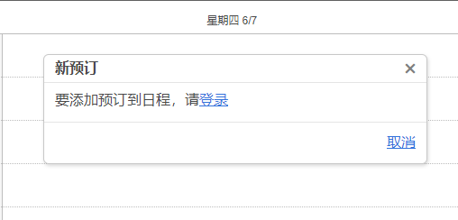

Step 3. User Login. Key in email address and password
用户登录界面，输入电子邮件和密码。
For the first time login, please click create new account.
第一次登录，请按创建新的账号。

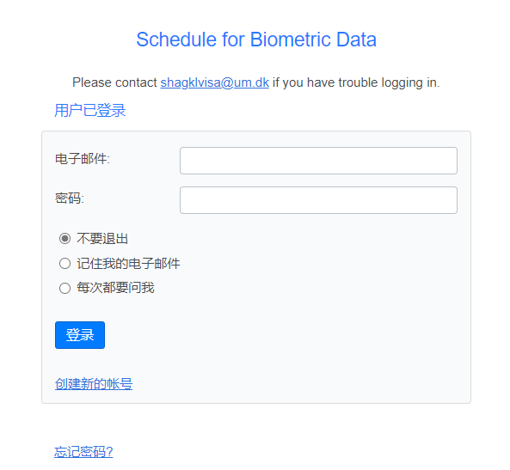

Step 4. The user successful login
用户登录成功

Step 5. Select the time you wish, key in full name, mobile number, passport number and FAO name, then select create reservation.
You can choose the available time with the white background. The time with grey background is invalid, which is not the service time.
One hour can make 12 applicants reservation maximum.

点击希望预约的时间进行预约，输入姓名（全名拼音）、手机号码、护照号码和对应外办名字，然后选择创建预定。
你可以选择白色背景的空白时间进行预约。灰色背景是无法预约的时间，由于其不在服务时间内。
一个小时最多可以预约12位申请人。
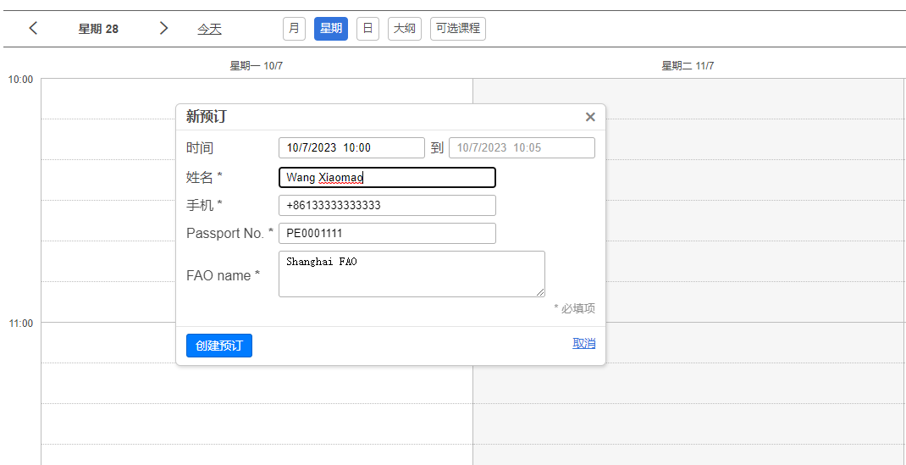

Step 6. The reservation successfully created, confirmation sent to bennwu@um.dk.
预约成功，确认函发往你自己注册时候使用的邮箱。

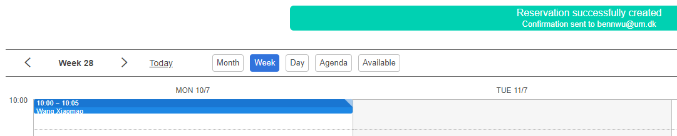

Step 7. You will receive a confirmation email sent from noreply@supersaas.com
确认函是从noreply@supersaas.com这个邮箱发出的。
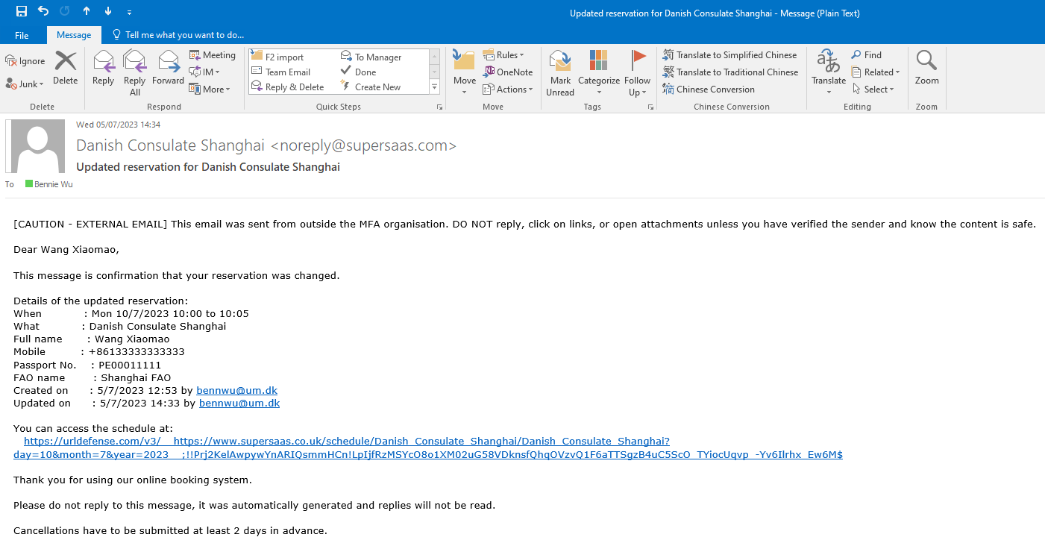

Step 8. If you wish to delete or update the reservation you made, press the blue button.
如果你希望删除或者更新预定，按蓝色键。
