e600B FAO Application Attachments Guide
600类签证上传材料清单
如何选择材料类别并命名
在“上传材料”(Attach document)页面中,请在以下列表中根据具体内容来选择对应的
“证明材料类别”(Evidence type),“文件类别”(Document Type),
并在“说明”(Description)一栏中根据下表来键入具体信息。

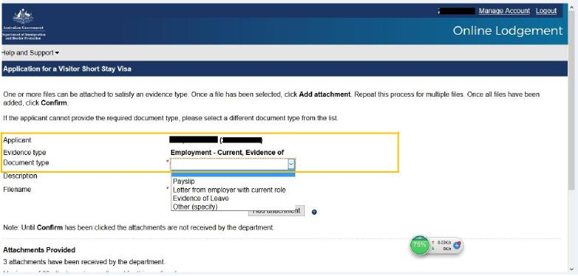

按照清单上传文件
上传文件必须为pdf或jpg格式。请参照如下附件列表选择相对应的 “证明材料类别”(Evidence type), “文件类别”( Document type), 并输入“具体说明”(Description):
Required document  所需材料 | Evidence Type  证明材料类别 | Document  Type  文件类别 | Description  具体说明
Invitation Letter  邀请信 | Invitation, Evidence of | Letter/Statement-Business/Employer | Invitation Letter
Dispatch Letter  派遣函 | Employment-Current, Evidence of | Letter from  employer with  current role | Dispatch Letter
Business License  营业执照 | Employment-Current, Evidence of | 请与派遣函扫描在同一文件中 | (To leave blank)  留白
Copy of the  Applicant’s Passport’s Biodata Page  申请人护照信息页 | Travel Document | Passport | (To leave Blank)  留白
National ID Card Scan Copy  身份证扫描件 | National Identity  Document (other than Passport) | National ID Card | (To leave blank)  留白

